Project Design Phase-II
Data Flow Diagram & User Stories

Date | 31 January 2025
Team ID
Project Name
Maximum Marks | 4 Marks

1. Data Flow Diagram (DFD)
DFD Level 0 (Context Diagram)

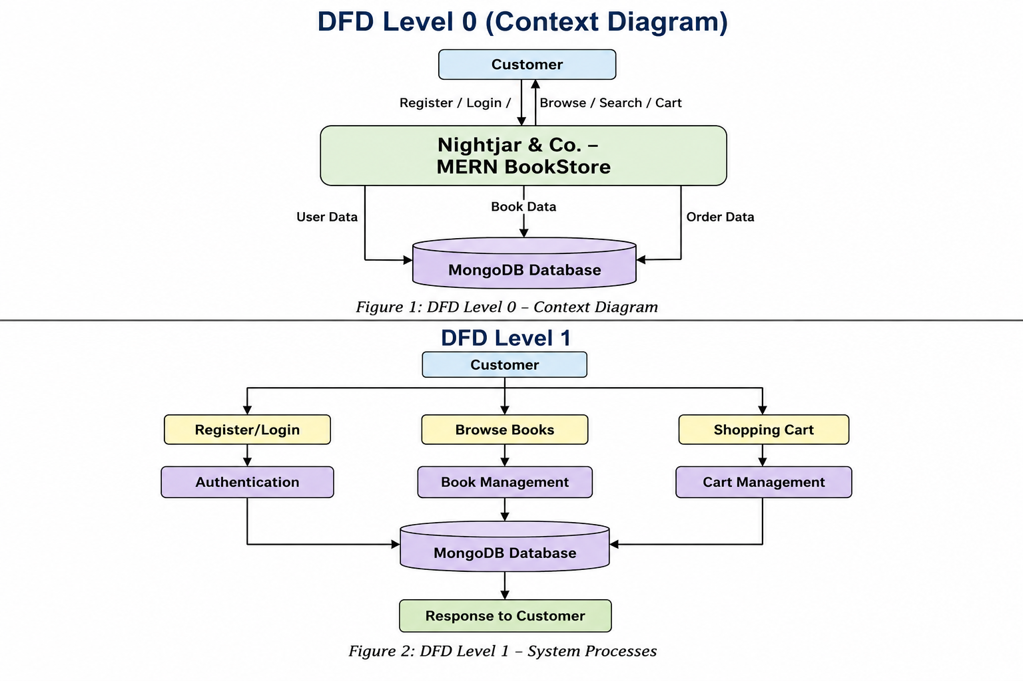
Figure 1: DFD Level 0 – Context Diagram

DFD Level 1


Figure 2: DFD Level 1 – System Processes

2. User Stories
User Type | Functional Requirement (Epic) | User Story No. | User Story / Task | Acceptance Criteria | Priority | Release
Customer (Web User) | Registration | USN-1 | As a user, I can register by providing my name, email, and password. | User account is created successfully. | High | Sprint-1
Customer (Web User) | Login | USN-2 | As a user, I can log in using my email and password. | User is redirected to the homepage after successful login. | High | Sprint-1
Customer (Web User) | Book Catalog | USN-3 | As a user, I can browse all available books. | Books are displayed correctly with images and details. | High | Sprint-2
Customer (Web User) | Search | USN-4 | As a user, I can search books by title. | Relevant books are displayed based on the search keyword. | High | Sprint-2
Customer (Web User) | Category Filter | USN-5 | As a user, I can filter books by category. | Only books from the selected category are displayed. | Medium | Sprint-2
Customer (Web User) | Book Details | USN-6 | As a user, I can view complete details of a selected book. | Book title, author, description, category, and price are displayed. | High | Sprint-2
Customer (Web User) | Shopping Cart | USN-7 | As a user, I can add books to my shopping cart. | Selected books are added to the cart successfully. | High | Sprint-2
Customer (Web User) | Shopping Cart | USN-8 | As a user, I can remove books from my shopping cart. | The selected book is removed and the cart is updated. | Medium | Sprint-2
Customer (Web User) | Profile | USN-9 | As a user, I can view my profile after logging in. | User profile information is displayed correctly. | Medium | Sprint-2
Administrator | Book Management | USN-10 | As an administrator, I can add new books to the catalog. | The new book is stored in the database and appears in the catalog. | High | Sprint-2
Administrator | Book Management | USN-11 | As an administrator, I can update existing book information. | Updated book details are reflected in the application. | High | Sprint-2
Administrator | Book Management | USN-12 | As an administrator, I can delete books from the catalog. | The selected book is removed successfully. | High | Sprint-2

